**AIM: Extract and load data using Pentaho Data integration tool**

**THEORY:**

Kettle (K.E.T.T.L.E - Kettle ETTL Environment) has been recently acquired by the Pentaho group and renamed to Pentaho Data Integration. Kettle is a leading open source ETL application on the market. It is classified as an ETL tool, however the concept of classic ETL process (extract, transform, load) has been slightly modified in Kettle as it is composed of four elements, ETTL, which stands for:

* Data extraction from source databases
* Transport of the data
* Data transformation
* Loading of data into a data warehouse Kettle is a set of tools and applications which allows data manipulations across multiple sources.

The main components of Pentaho Data Integration are:

**Spoon** – It is a graphical tool which make the design of an ETTL process transformations easy to create. It performs the typical data flow functions like reading, validating, refining, transforming, writing data to a variety of different data sources and destinations. Transformations designed in Spoon can be run with Kettle Pan and Kitchen.

**Pan** – It is an application dedicated to run data transformations designed in Spoon.

**Chef** – It is a tool to create jobs which automate the database update process in a complex way.

**Kitchen** – It is an application which helps execute the jobs in a batch mode, usually using a schedule which makes it easy to start and control the ETL processing.

**Carte** – It is a web server which allows remote monitoring of the running Pentaho Data Integration ETL processes through a web browser.

**ETL Process Transformation:**

As the name suggested ETL stands for Extract Transform and Load.Just like the name applies ETL tool Extracts data from the source.Transforms the data while in transit and then it loads the data in to Specified database.

* **Sort Transformation:**

The Sort transformation sorts input data in ascending or descending order and copies the sorted data to the transformation output. You can apply multiple sorts to an input; each sort is identified by a numeral that determines the sort order. The column with the lowest number is sorted first, the sort column with the second lowest number is sorted next, and so on.

* **Add Sequence:**

The Add sequence step adds a sequence to the stream. A sequence is an everchanging integer value with a specific start and increment value. You can either use a database sequence to determine the value of the sequence, or have it generated by Kettle.

* **Concat:**

The Concat Fields step is used to concatenate multiple fields into one target field. The fields can be separated by a separator and the enclosure logic is completely compatible with the Text File Output step.

* **Unique Rows:**

The Unique rows step removes duplicate rows from the input stream(s).

* **Split:**

The Split Fields step allows you to split fields based on delimiter information

**Features of Pentaho:**

Pentaho Reporting primarily includes a Reporting Engine, a Report Designer, a

Business Intelligence (BI) Server. It comes loaded with the following features − • Report Designer − Used for creating pixel perfect report.

* Metadata Editor − Allows to add user-friendly metadata domain to a data source. • Report Designer and Design Studio − Used for fine-tuning of reports and ad-hoc
* reporting.
* Pentaho user console web interface − Used for easily managing reports and
* analyzing views.
* Ad-Hoc reporting interface − Offers a step-by-step wizard for designing simple
* reports. Output formats include PDF, RTF, HTML, and XLS.
* A complex scheduling sub-system − Allows users to execute reports at given
* intervals.
* Mailing − Users can email a published report to other users.

1. **Demo of reading and writing csv file.**

**Step 1. Open Data Integration folder**

**Step 2. Double click on spoon(Windows Batch file)**

**Step 3. A welcome! window appears with some useful links for you to see.**

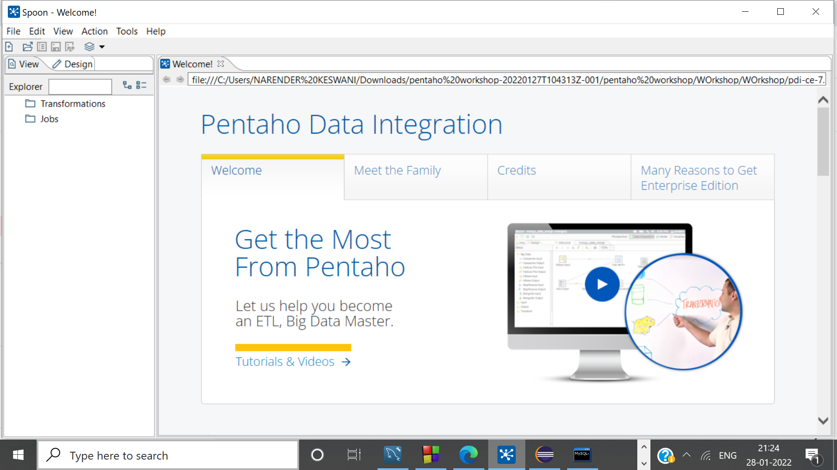

**Step 4: Create new transformation, in input drag & drop the csv file.**

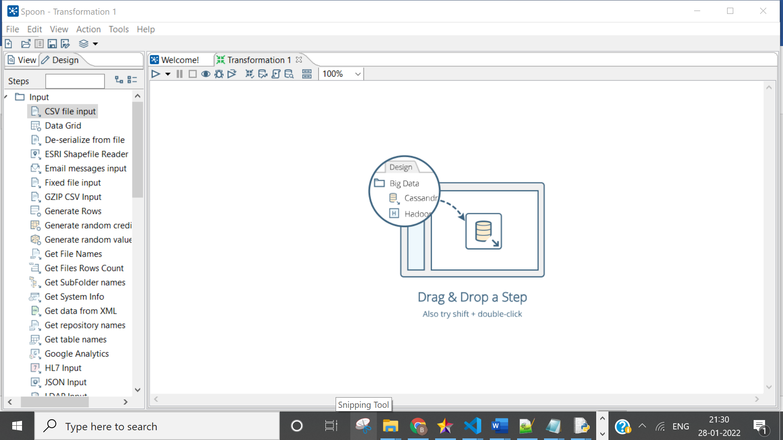

**Step 5: Specify the path of input file**

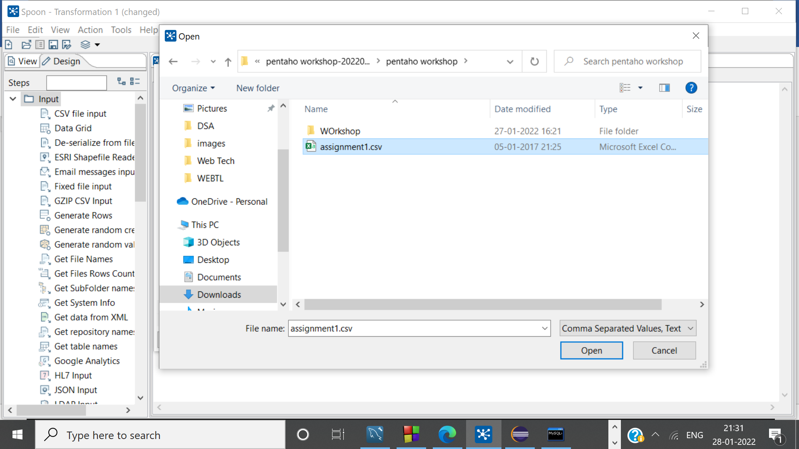

**Step 6: Check Preview Data**

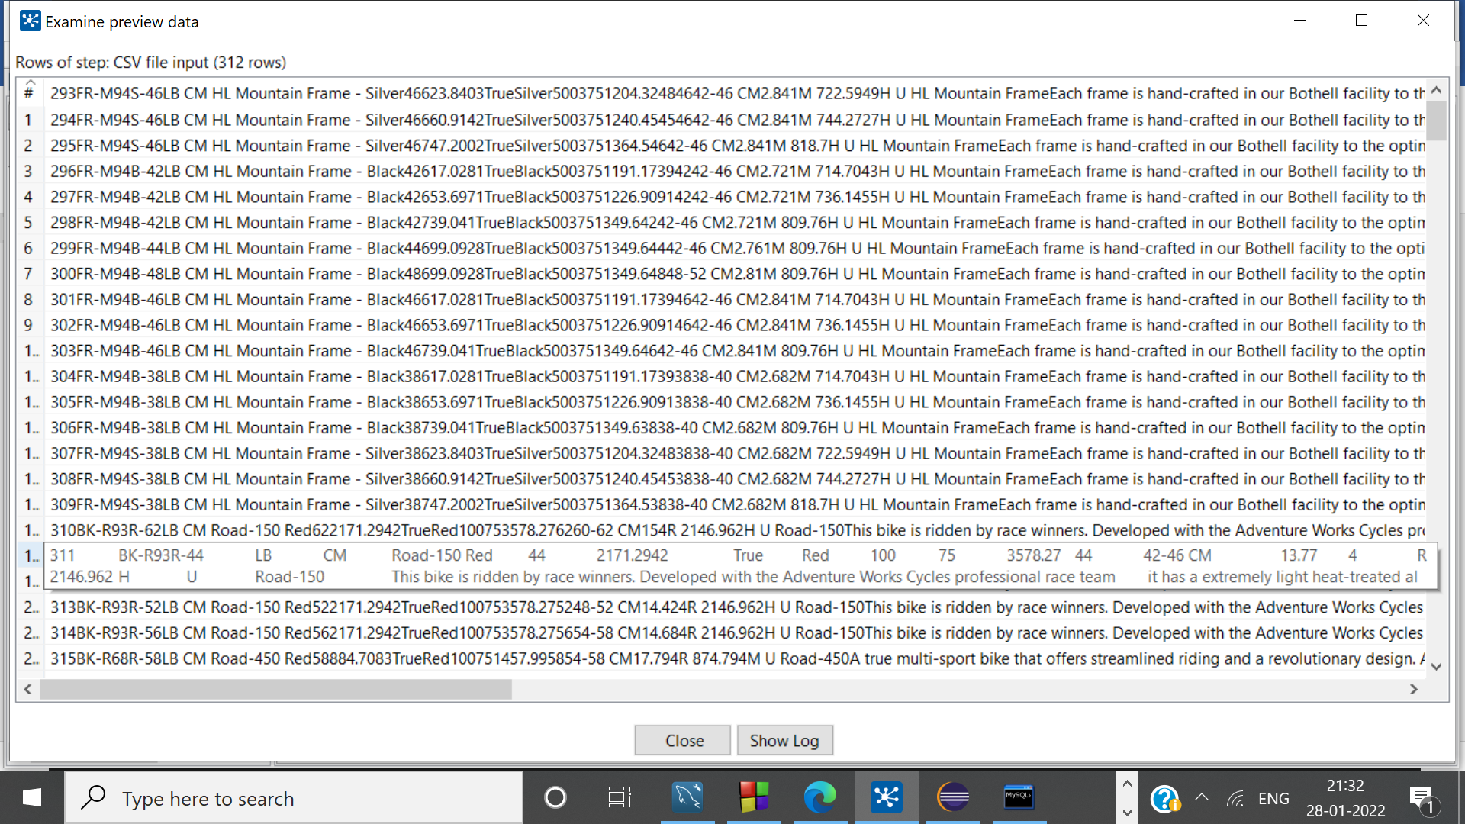

**Step 7: Now, drag & drop csv output file from output section**

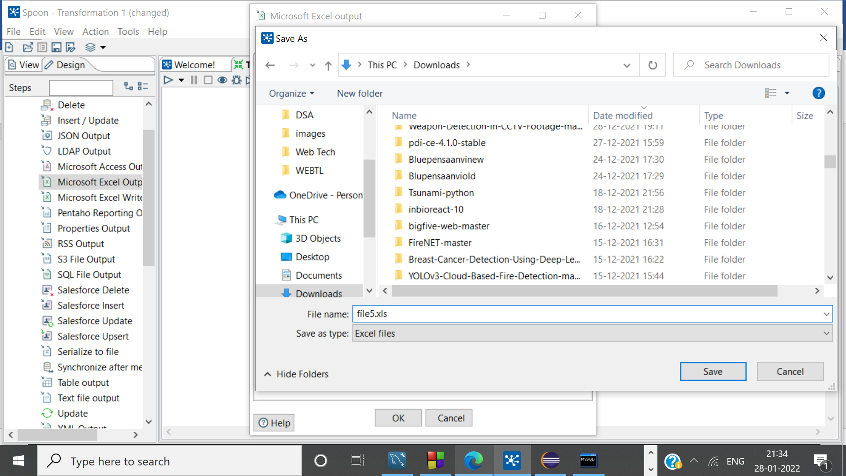

1. **SORT ROWS TRANSFORMATIOON:**

**Step 1. In the Pentaho Data Integration tools (Spoon), Pull down the File menu and select the New menu item followed by Transformation.**

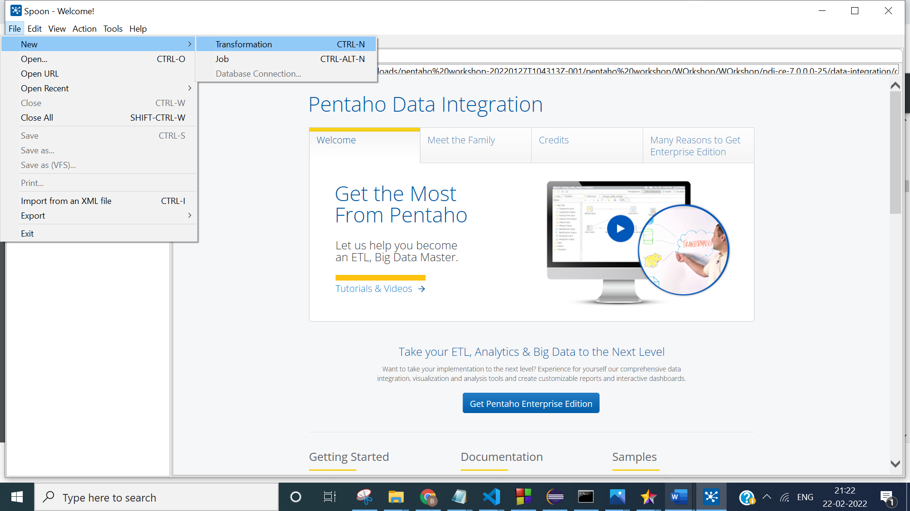

**Step 2. Open up the Input folder and drag and drop the Microsoft excel input step on to the transformation window.**

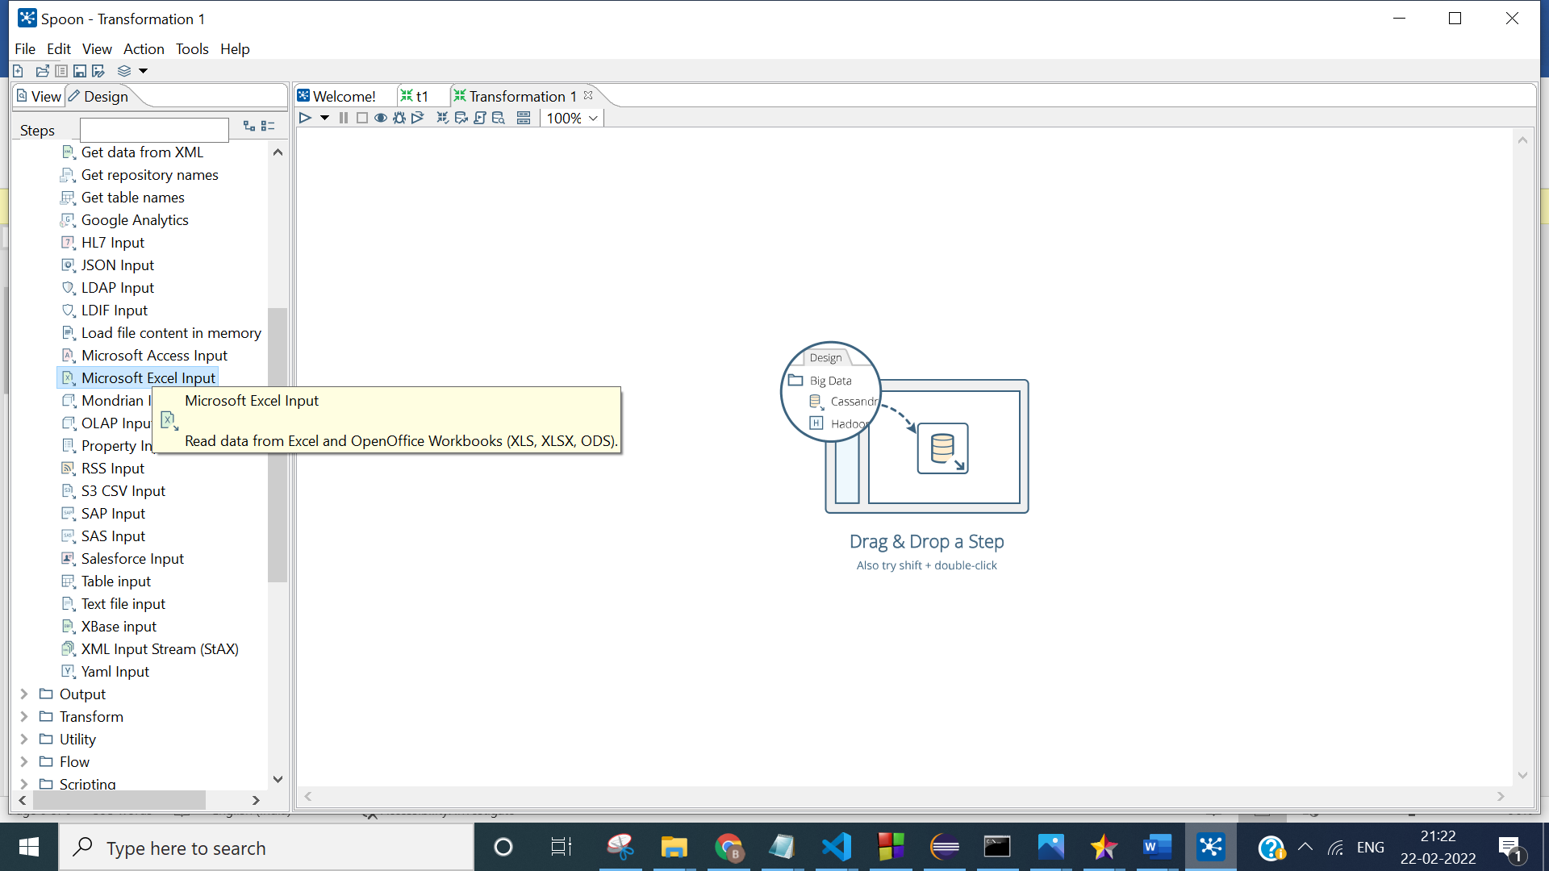

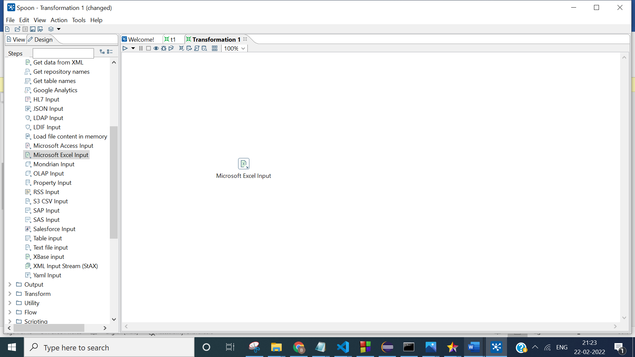

**Step 3. Double-click on the Microsoft Excel Input step to view its properties Click on the Browse button next to Filename field and navigate to the folder with the Excel files. Select the Excel file as shown below and then click the Open button. After that click on ADD button to add excel file .**

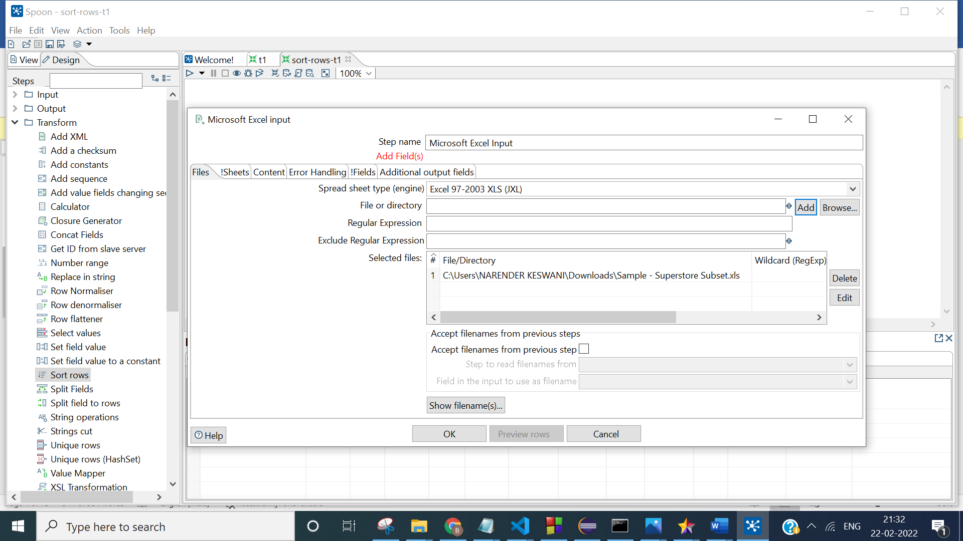

**Step 4: Double-click on the Microsoft Excel output step to view its properties Click on the Browse button next to Filename field and navigate to the folder to store the output.**

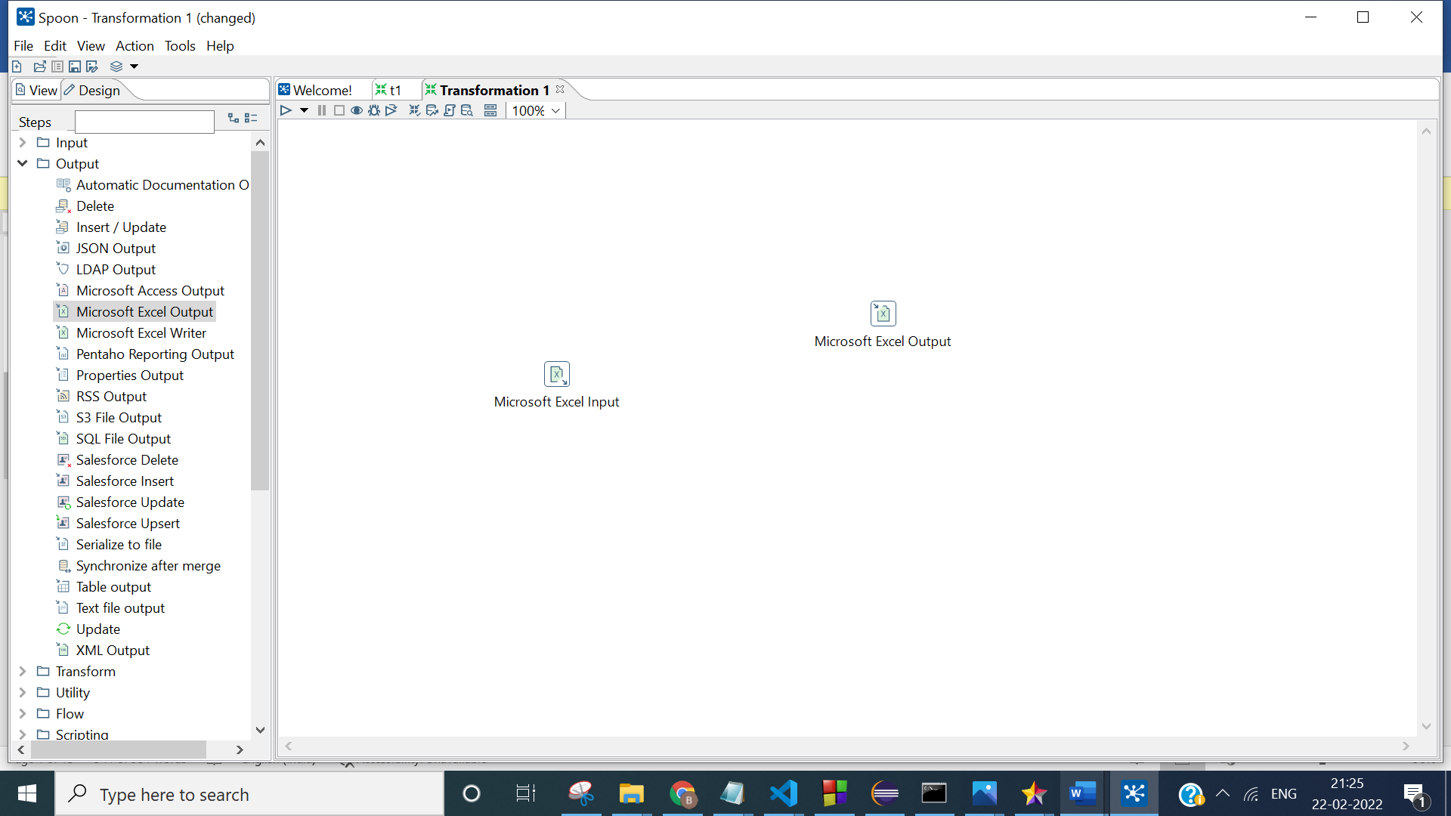

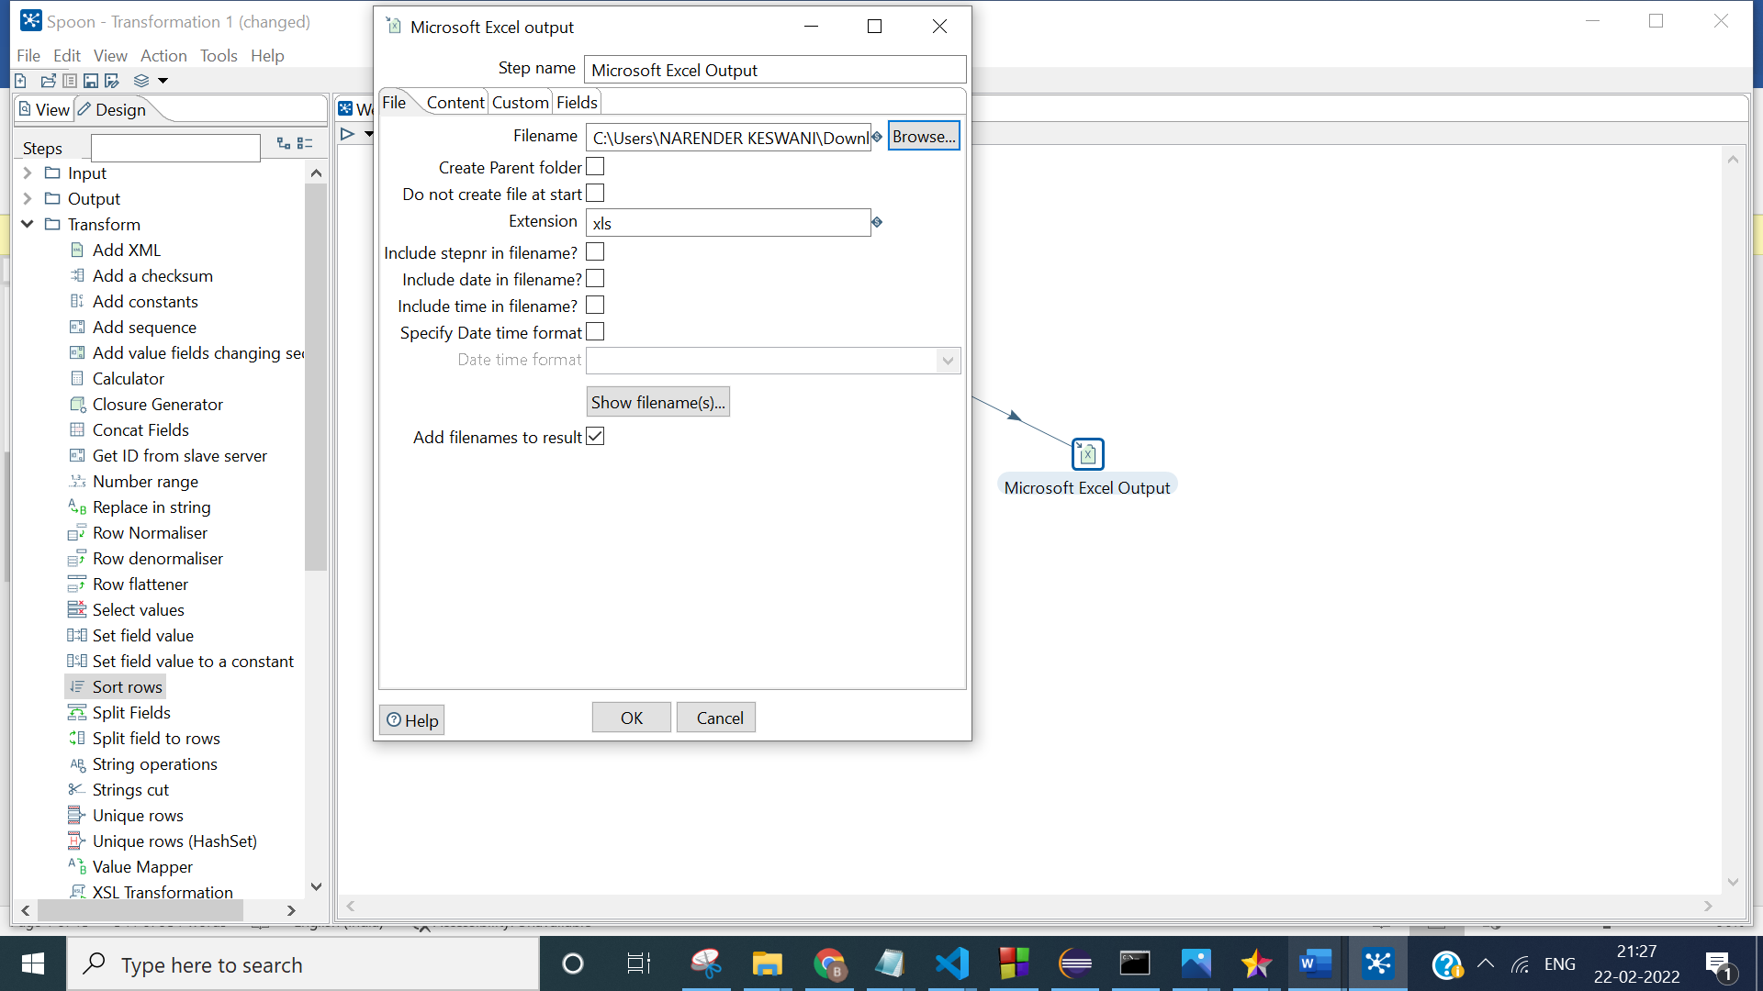

**Step 5: Drag & Drop sort rows from the transformation sections.**

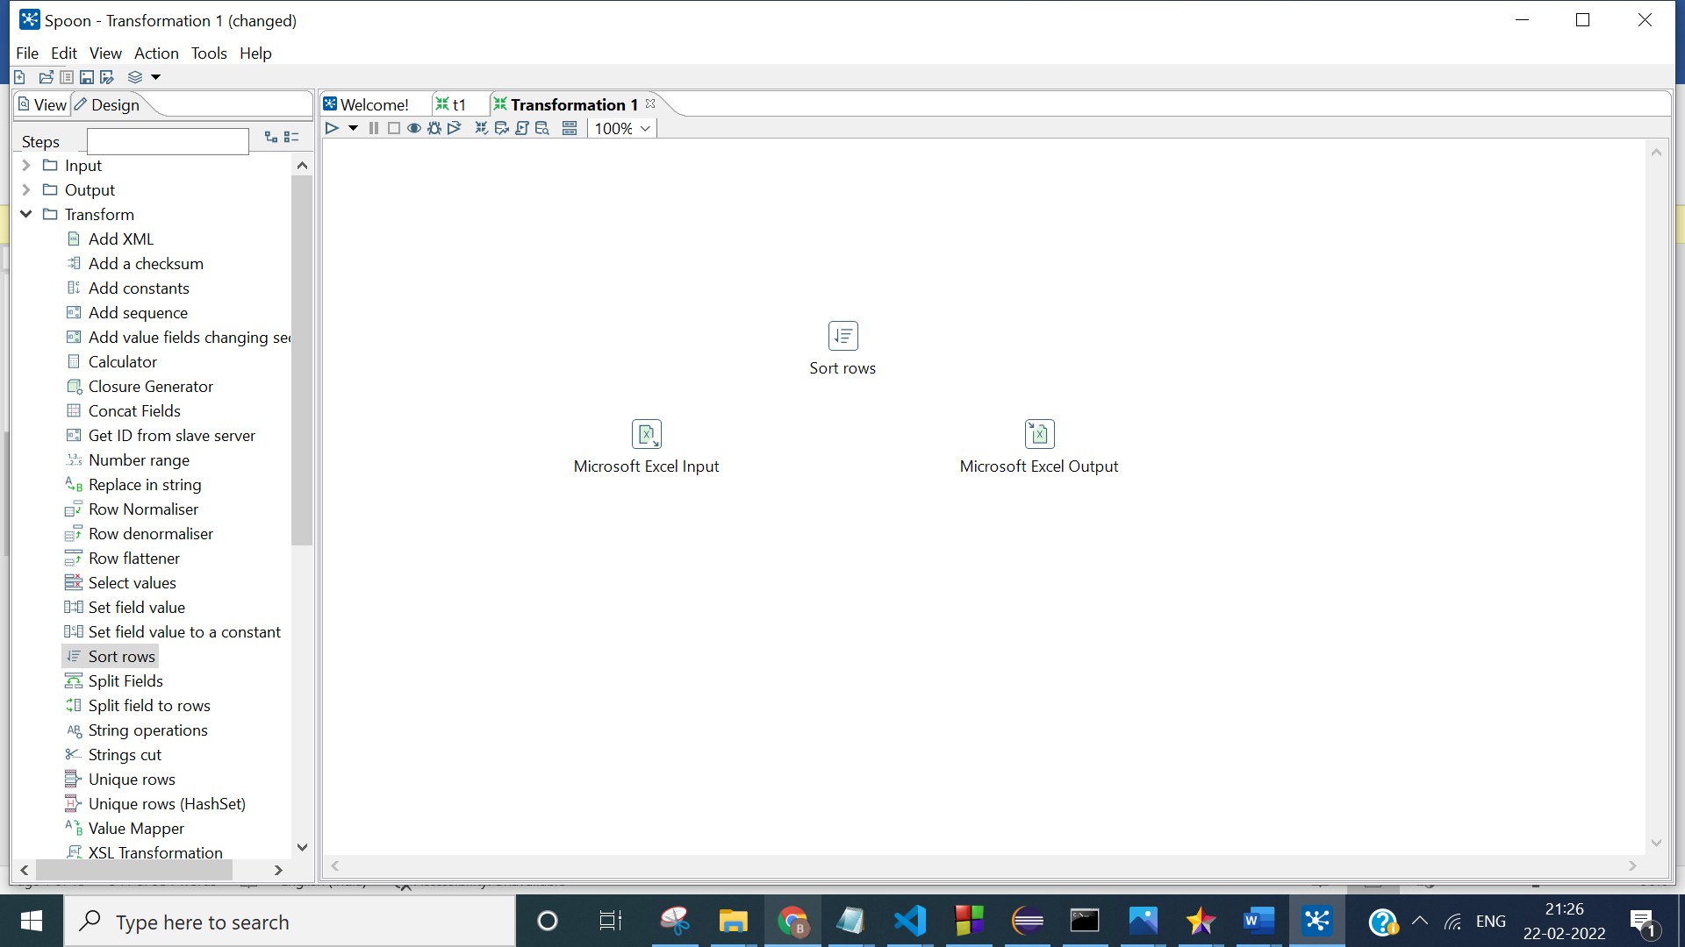

**Step 6: Create connections among input, sort & output using hops.**

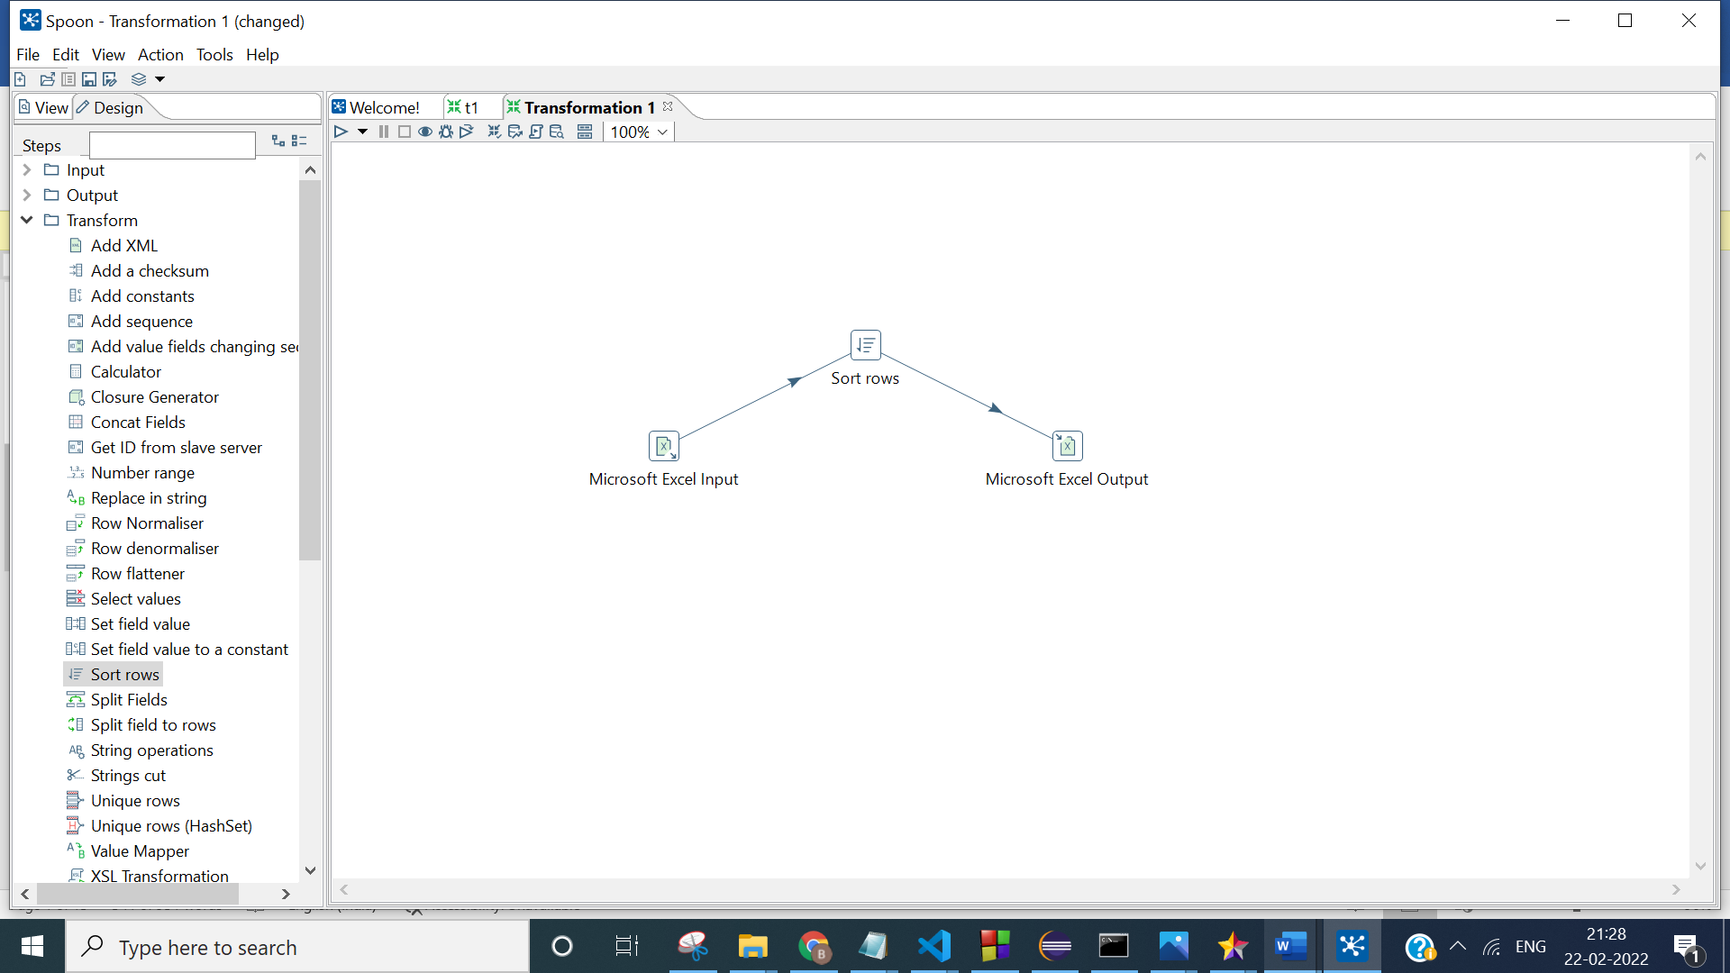

**Step 7: Execute the program:**

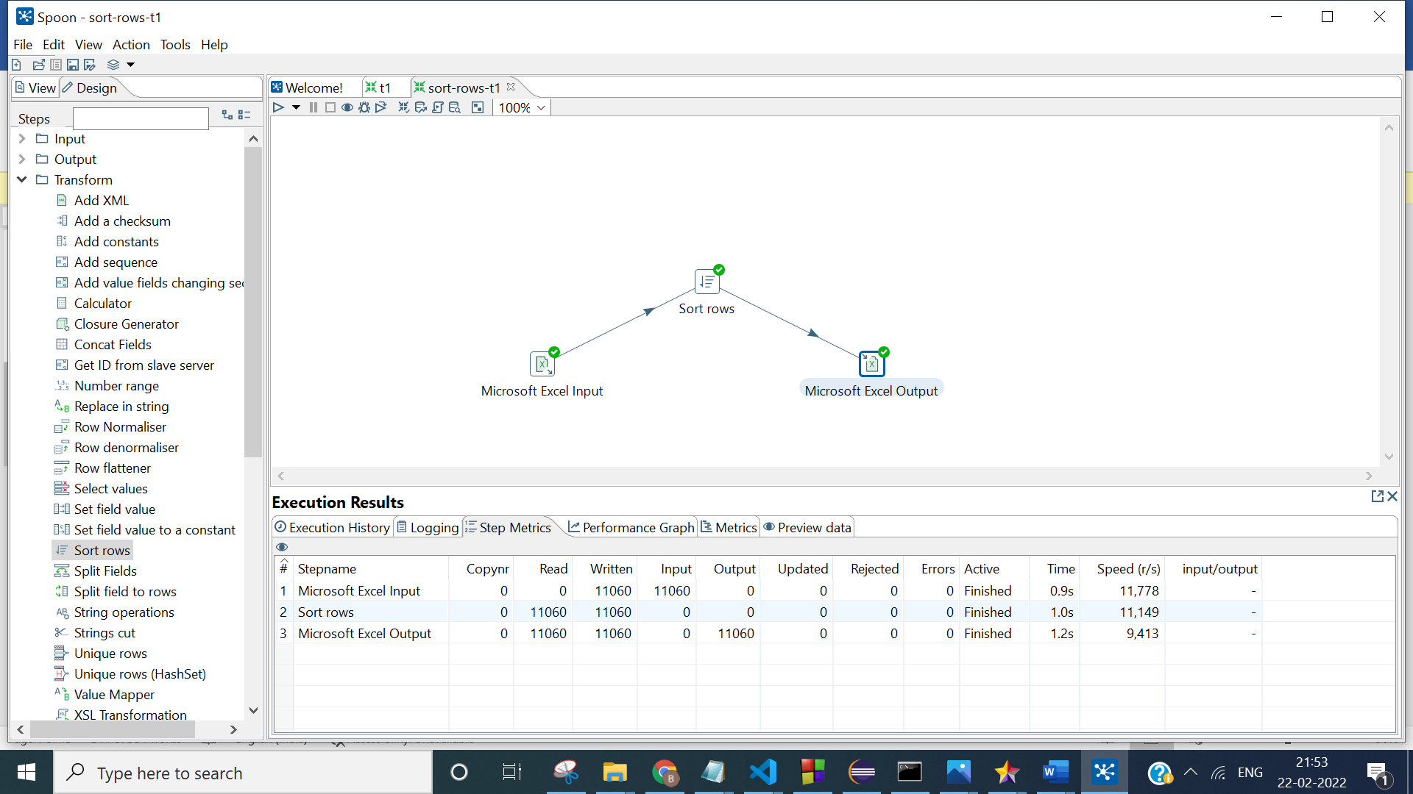

**OUTPUT:**

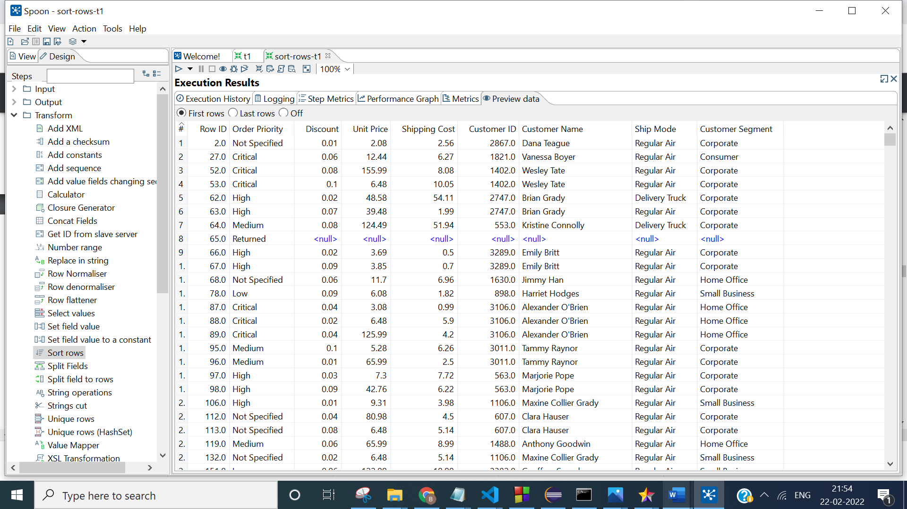

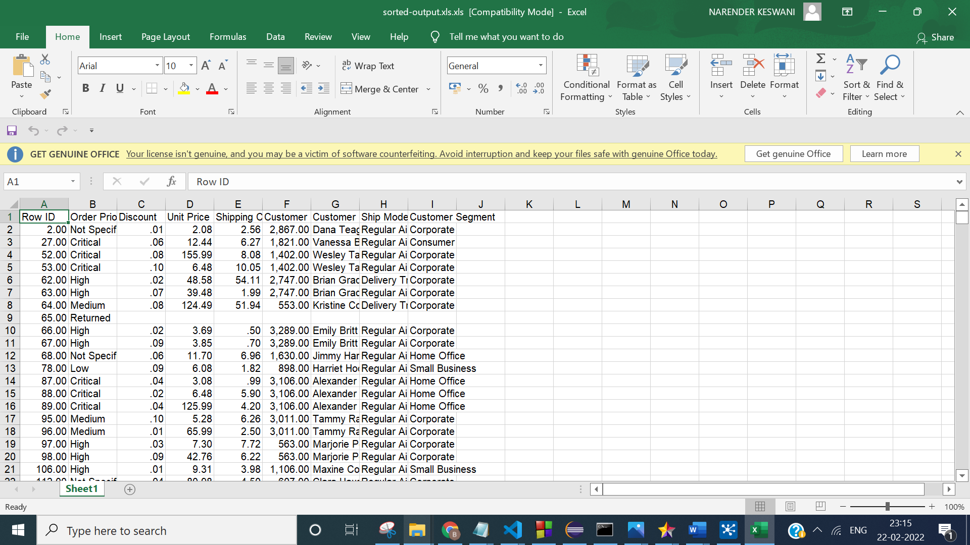

1. **SEQUENCE TRANSFORMATION:**

**Step 1. Open up the Input folder and drag and drop the Microsoft excel input step on to the transformation window.**

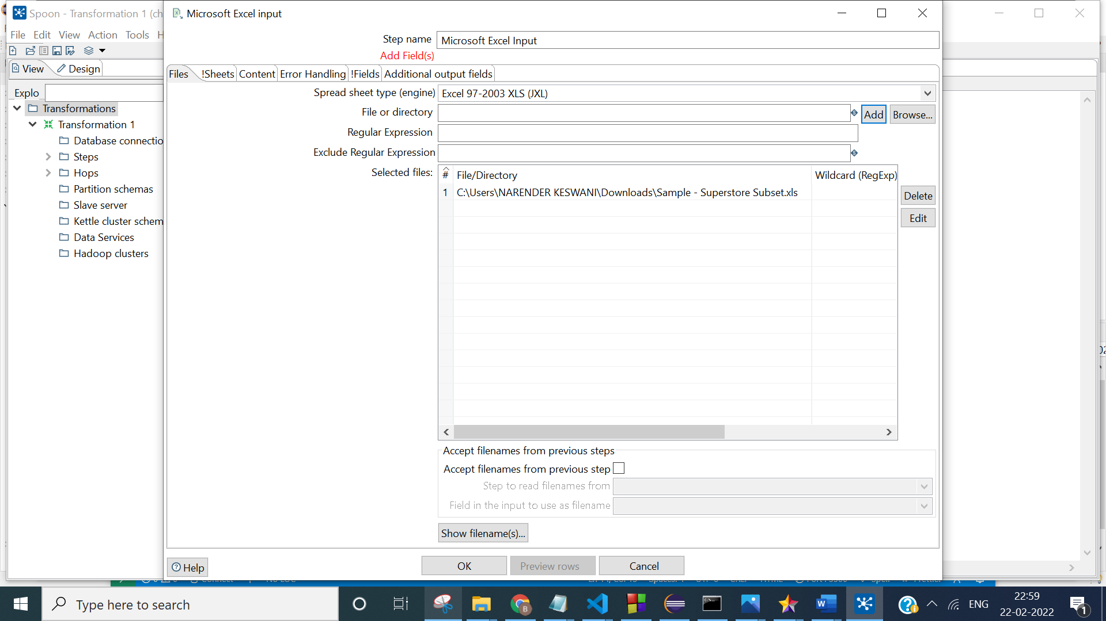

**Step 2. Open up the Transformation folder and drag and drop the Add Sequence and config according to requirements**

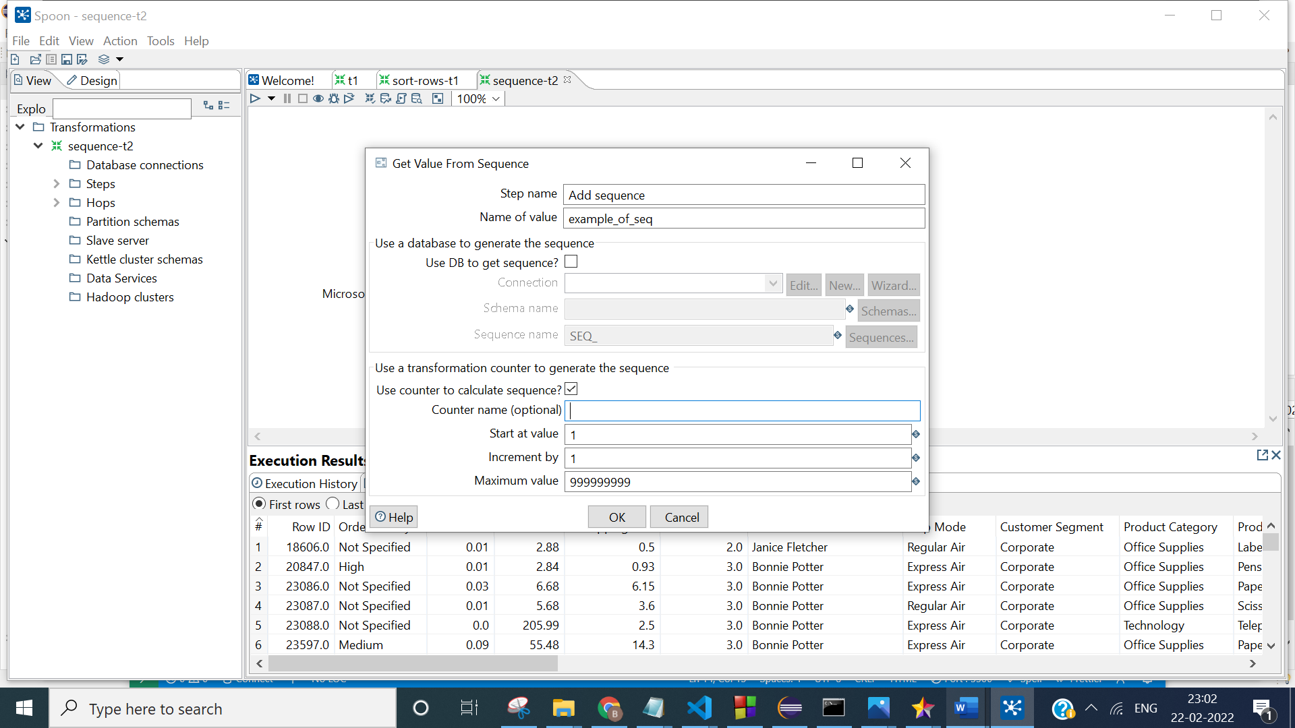

**Step 3. Open up the Output folder and drag and drop the Microsoft excel output and config it.**

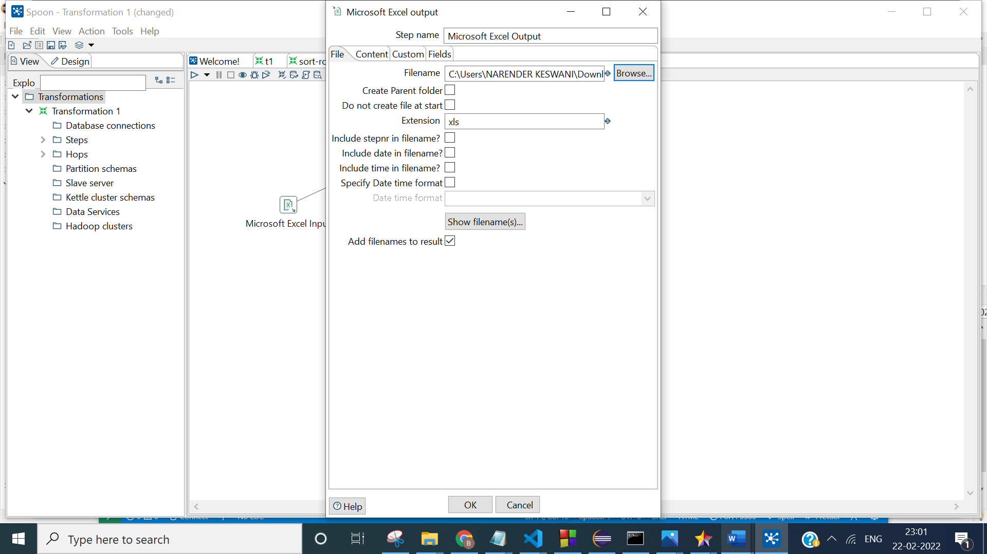

**Step 4. Execute the transformation.**

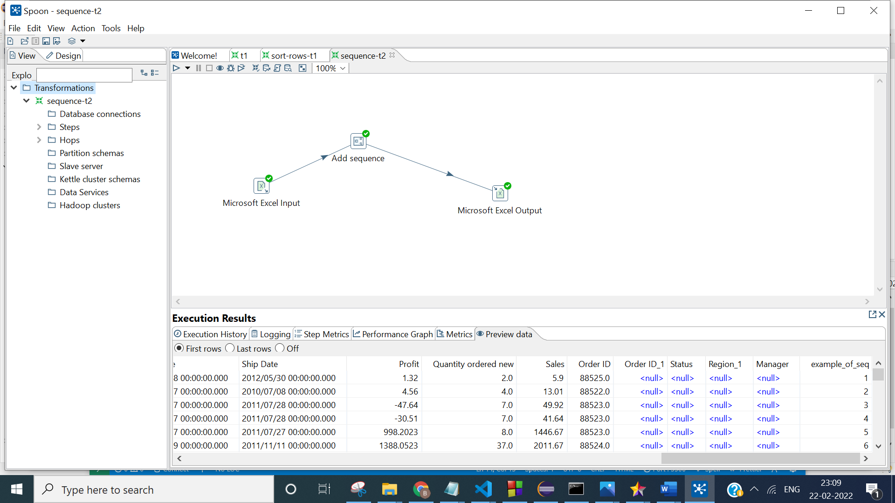

**OUTPUT:**

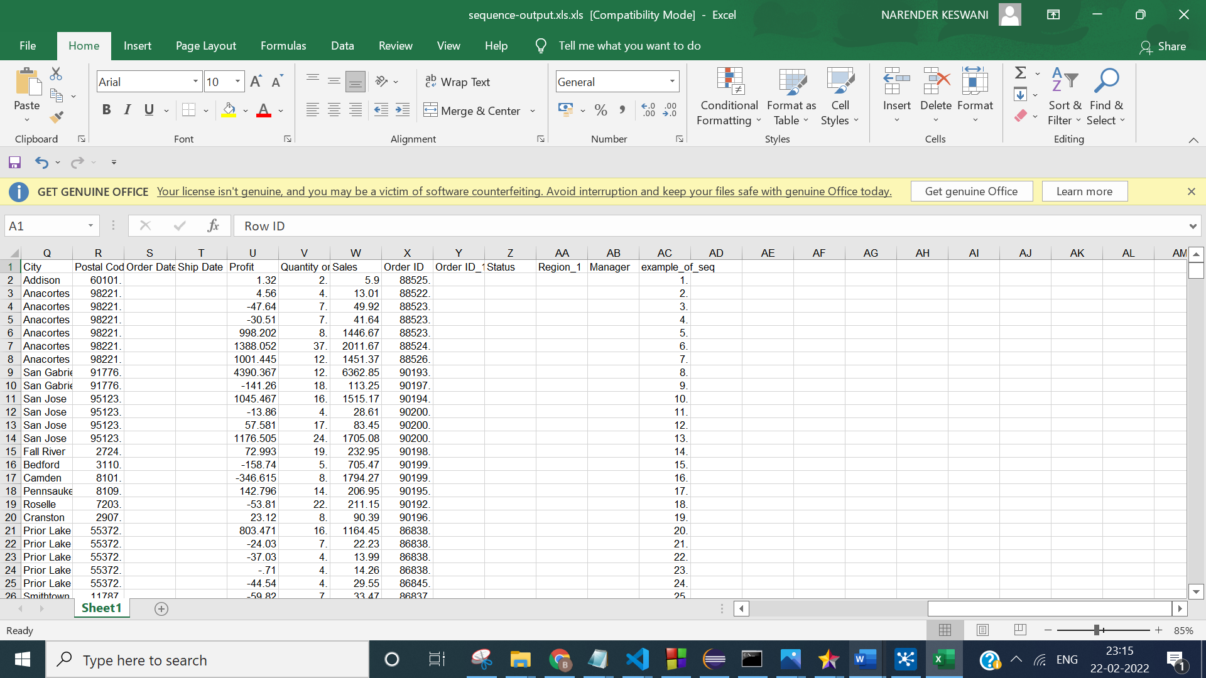

1. **CALCULATOR (SUM):**

**Step 1. Open up the Input folder and drag and drop the Microsoft excel input step on to the transformation window.**

**Step 2. Open up the Transformation folder and drag and drop the calculator and config it according to requirements.**

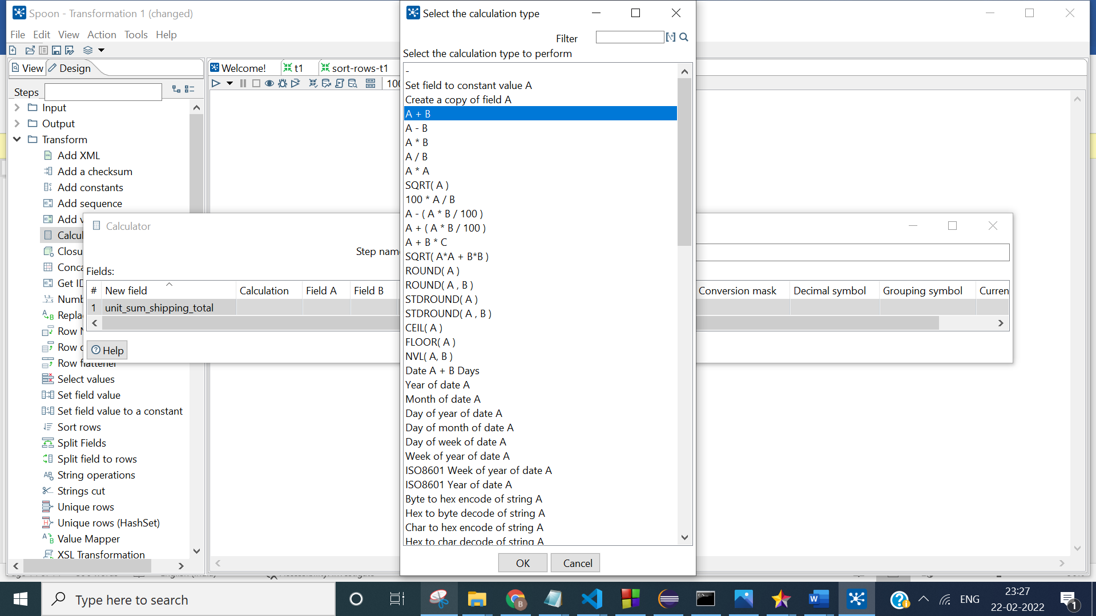

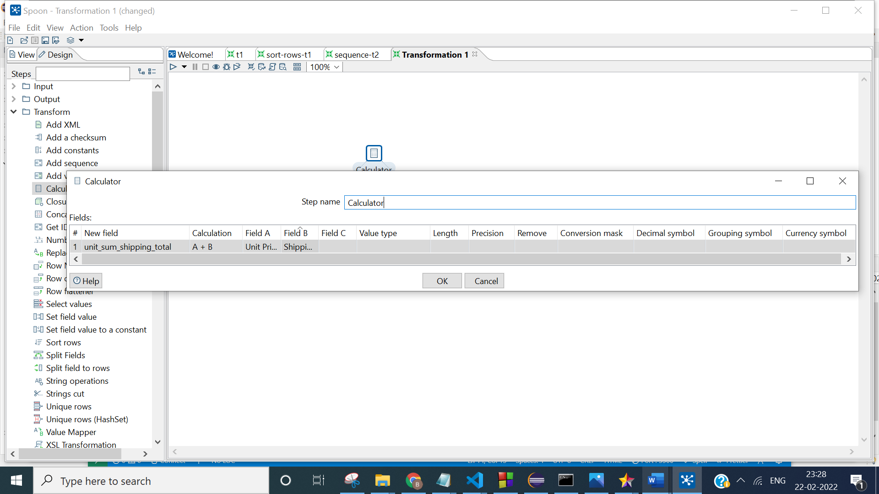

**Step 3. Open up the output folder and drag and drop the Microsoft excel output step on to the transformation window.**

**Step 4. Execute the transformation**

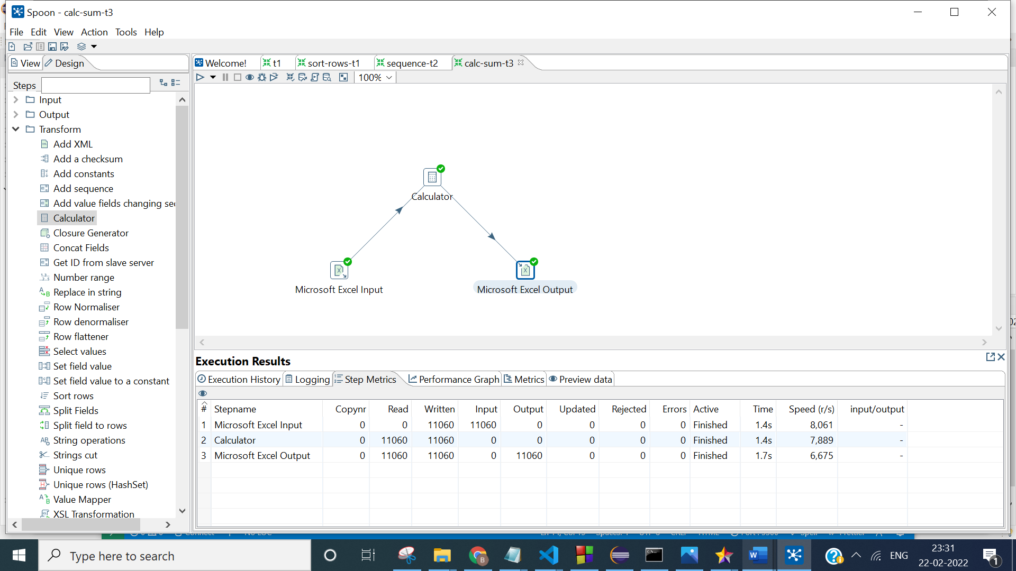

**OUTPUT:**

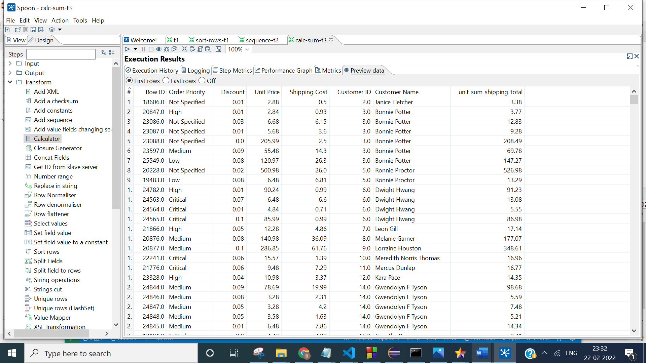

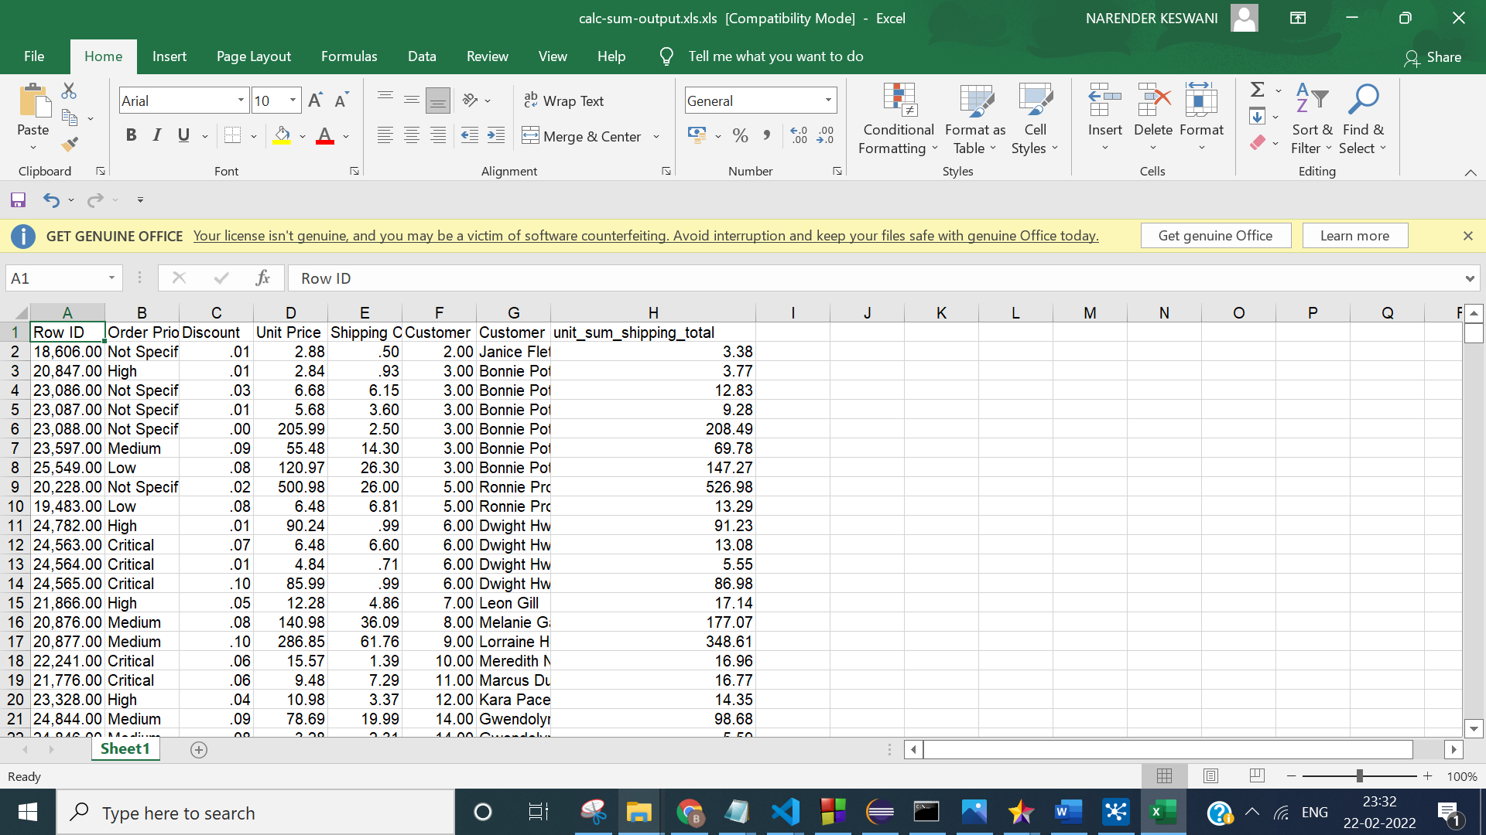

1. **Number Range:**

**Step 1. Open up the Input folder and drag and drop the Microsoft excel input step on to the transformation window.**

**Step 2. Open up the Transformation folder and drag and drop the number range and config it according to requirements.**

**Step 3. Open up the output folder and drag and drop the Microsoft excel output.**

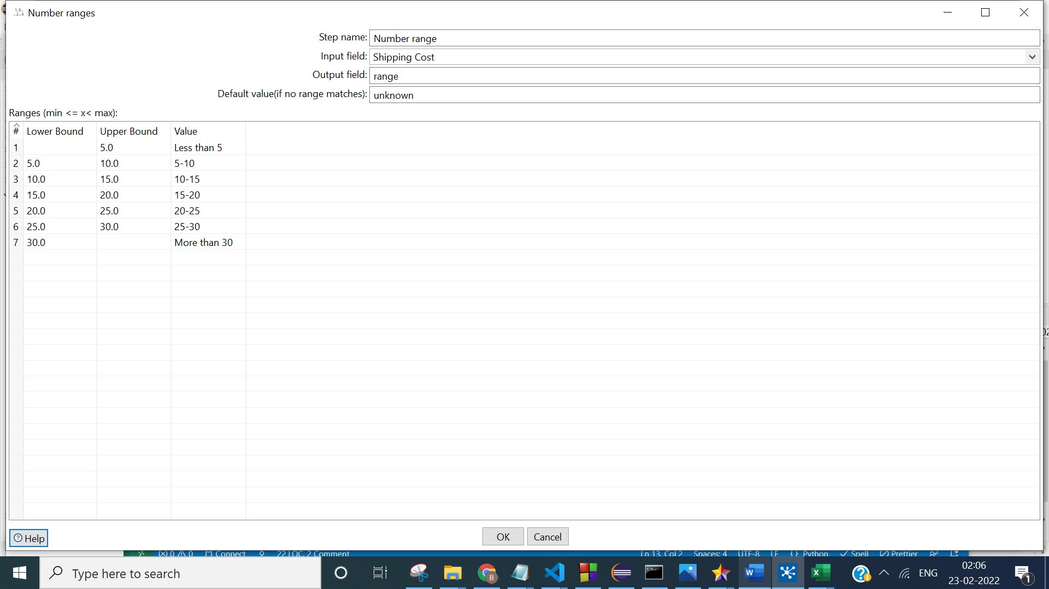

**Step 4. Execute the transformation**

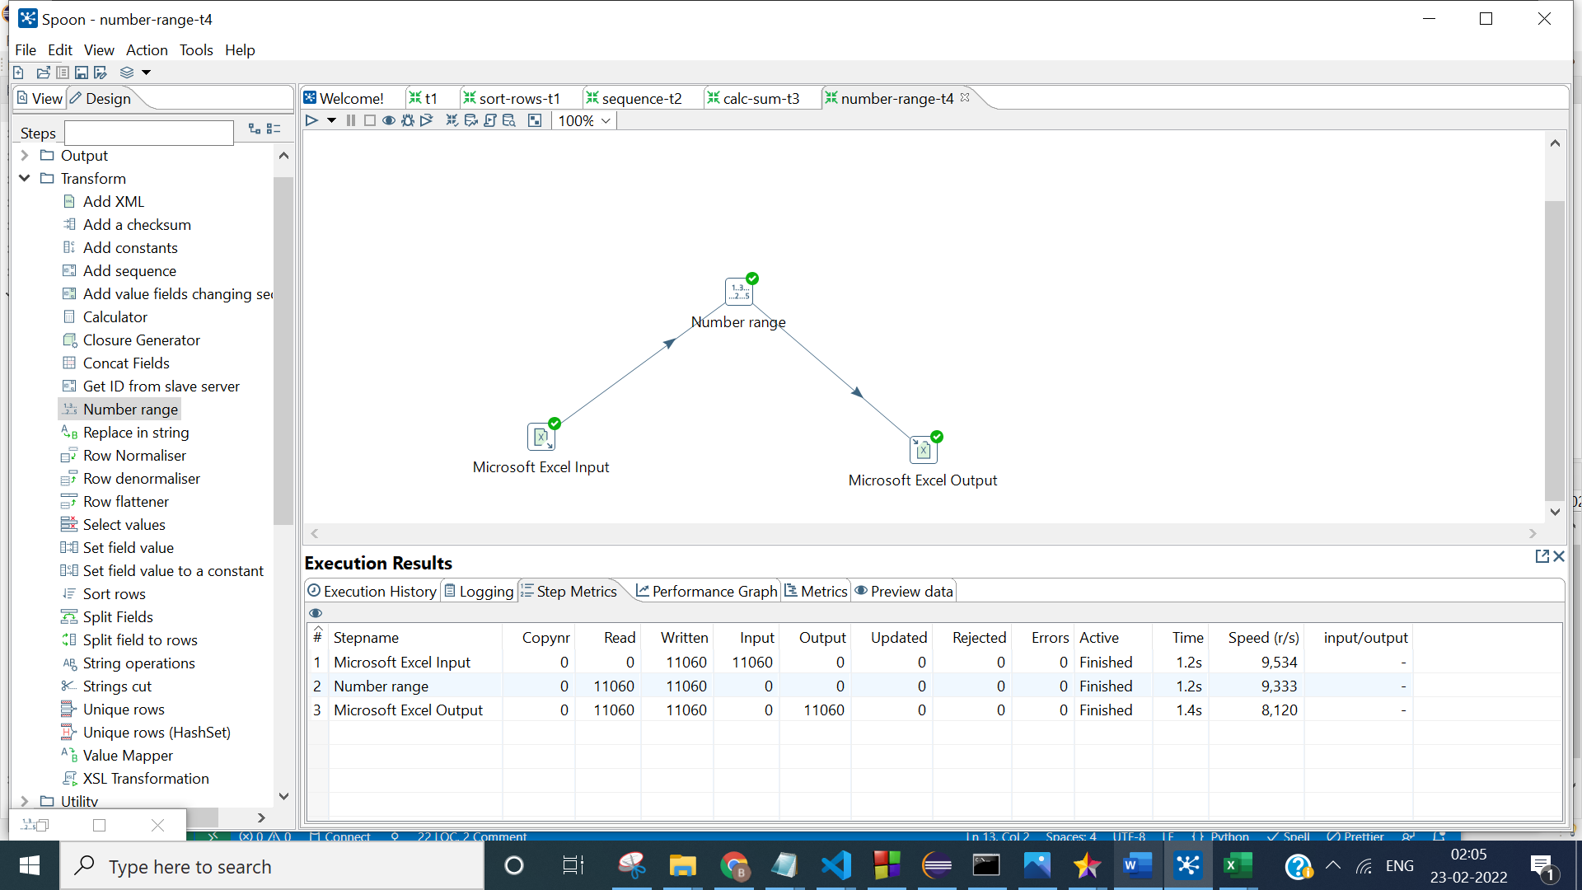

**OUTPUT:**

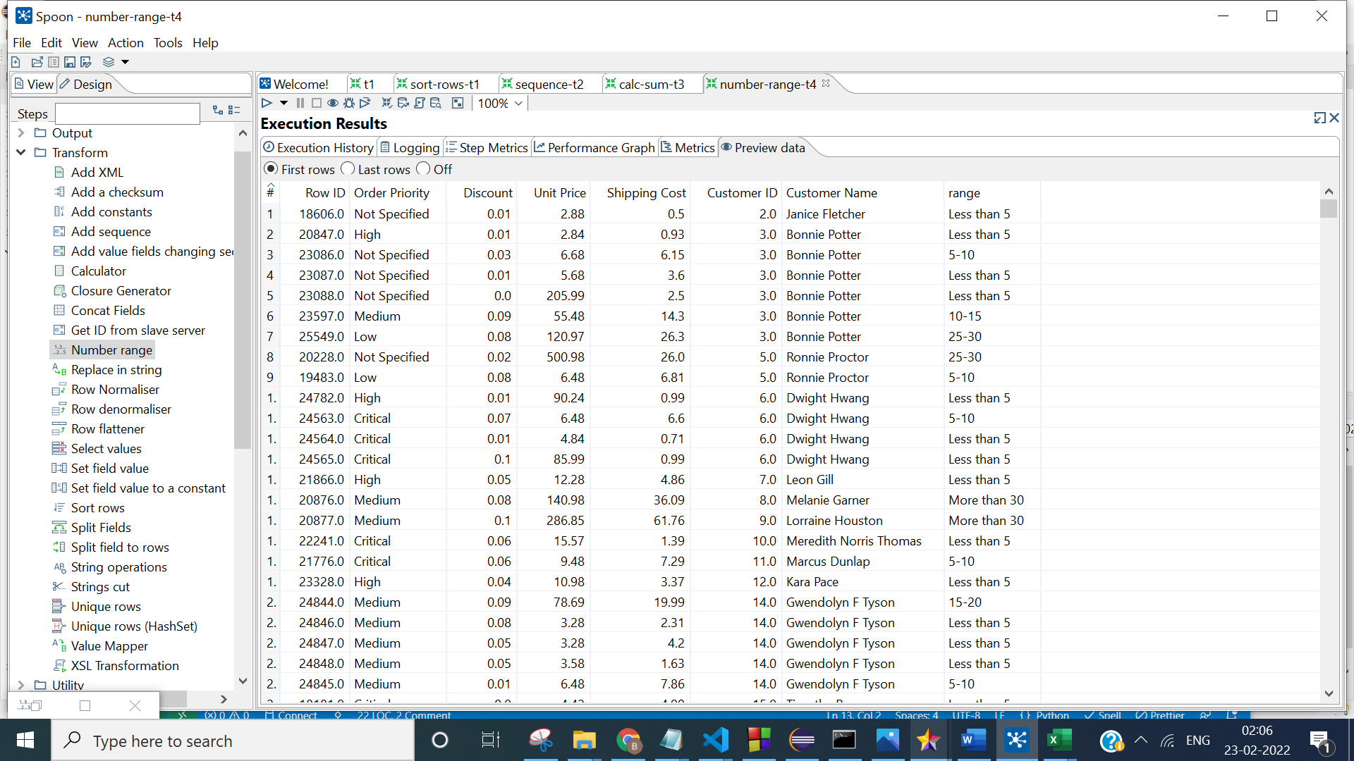

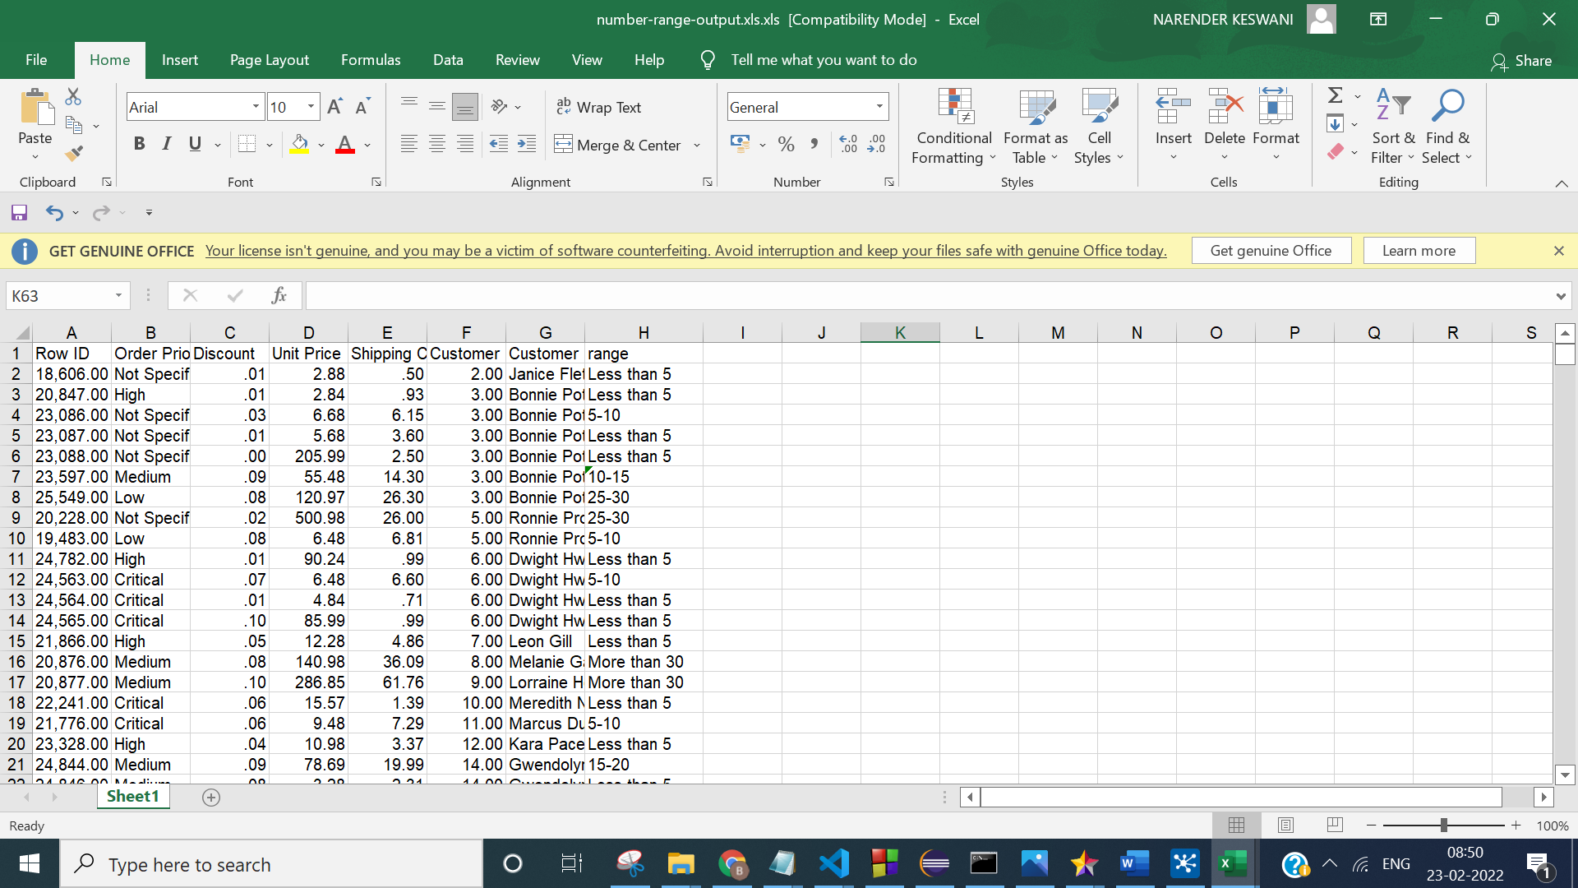

1. **CONCAT TRANSFORMATION:**

**Step 1. Open up the Input folder and drag and drop the Microsoft excel input step on to the transformation window.**

**Step 2. Open up the Transformation folder and drag and drop the concat fields and config it according to requirements.**

**Step 3. Open up the output folder and drag and drop the Microsoft excel output.**

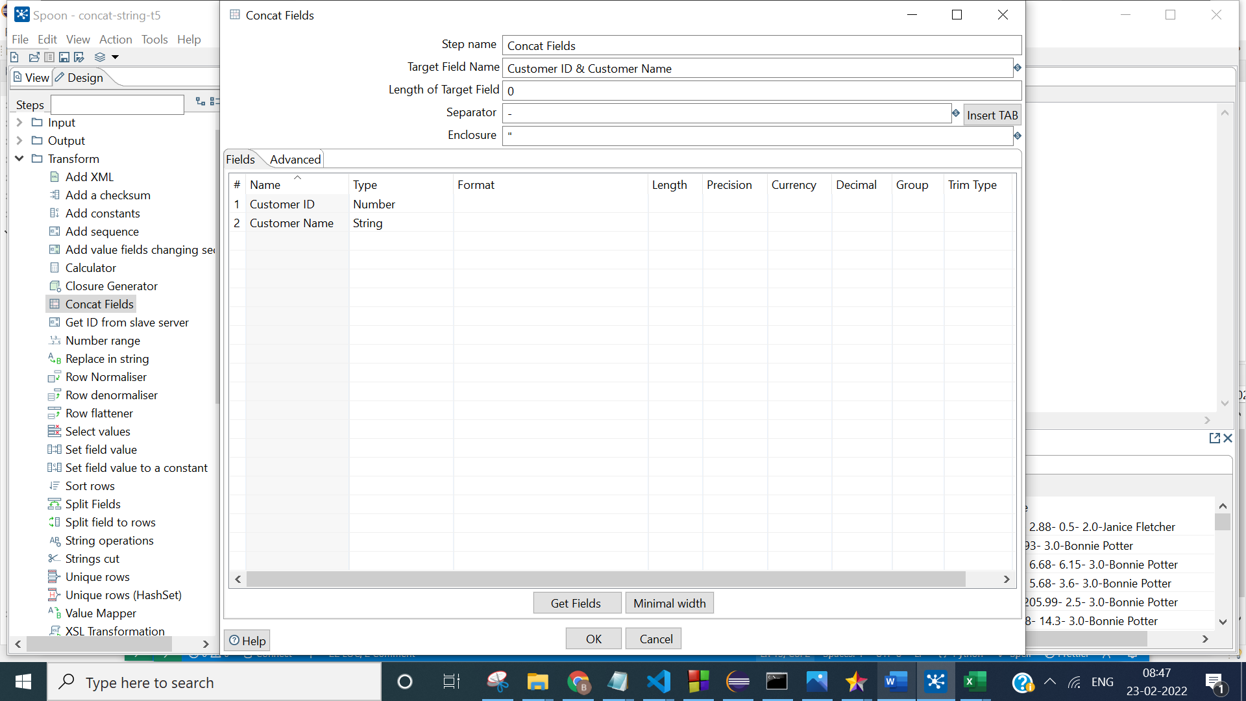

**Step 4. Execute the transformation**

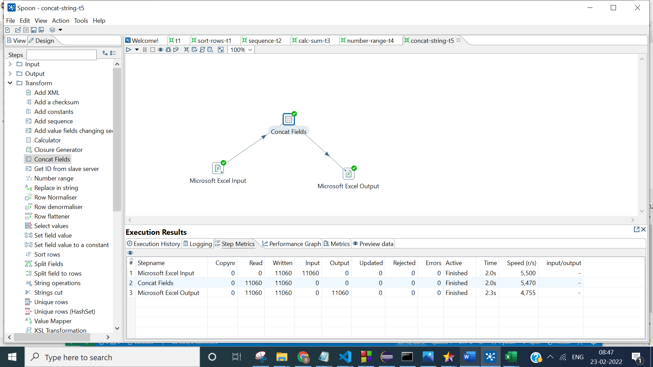

**OUTPUT:**

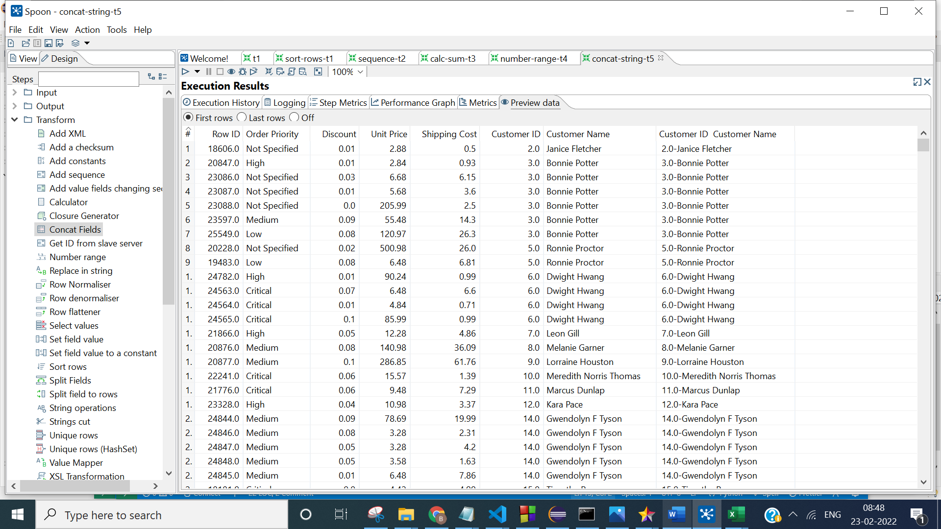

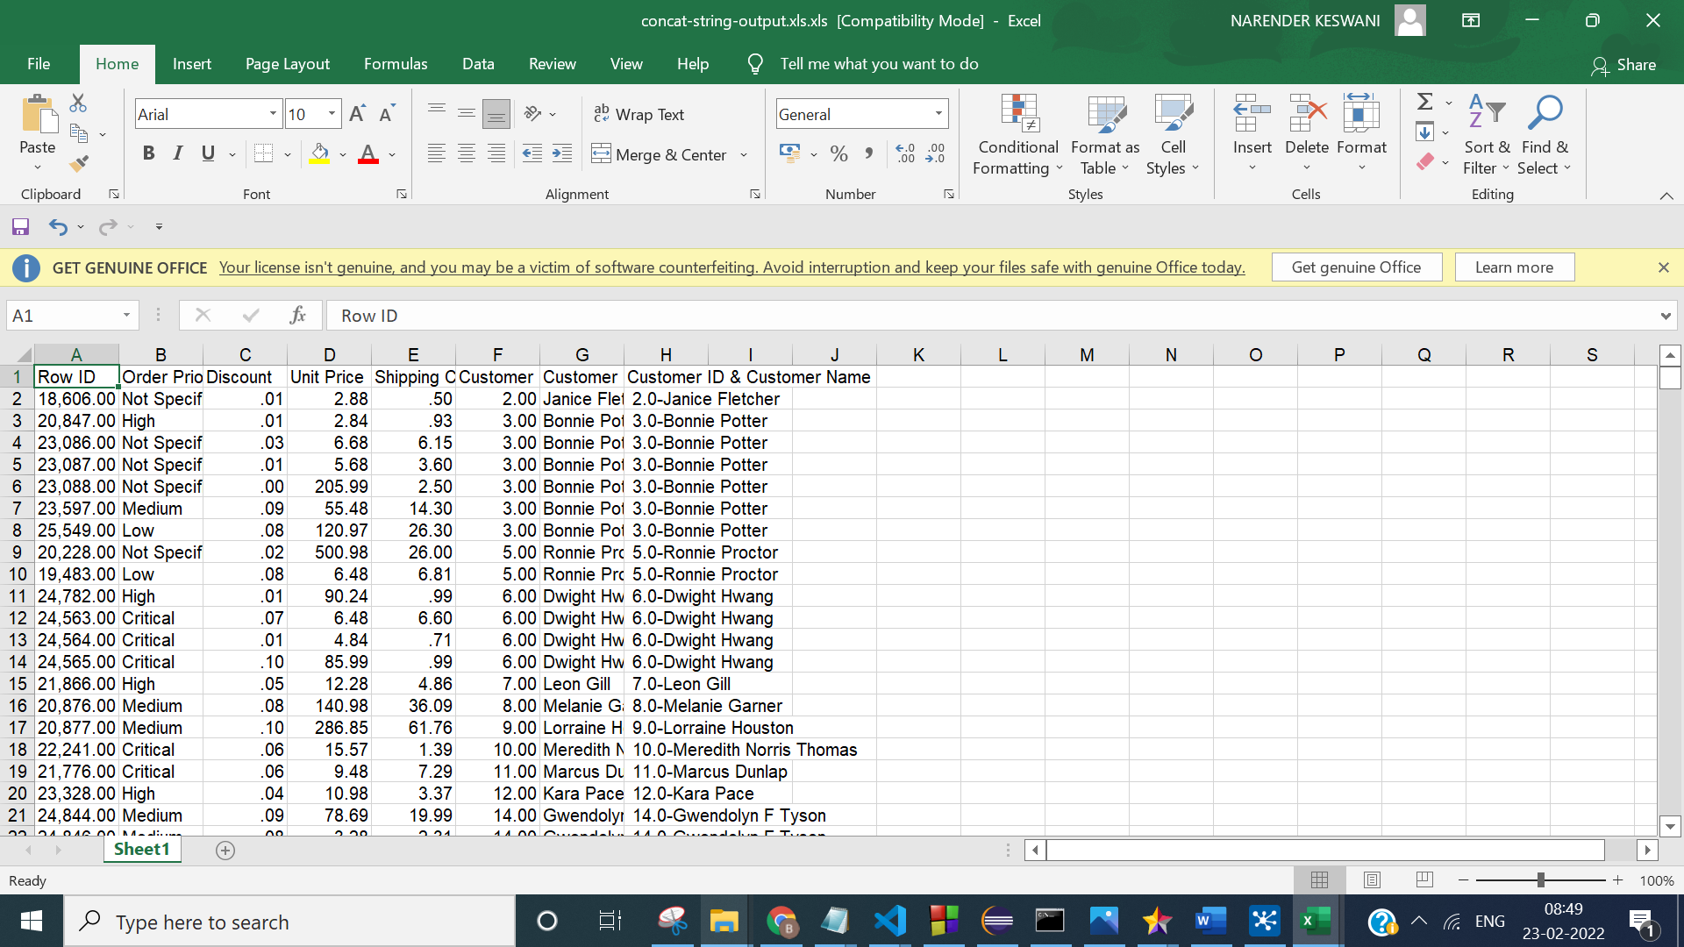

**CONCLUSION:**

From this practical, I have learned how to do ETL (Extract, Transform, Load) in Pentaho.